# Part 1: Start the Battleship game

Part 1 of this case study has you create a simple single-player Battleship game that allows the user to guess locations on the game board shown below. If the location is a hit, an X is placed on the game board. If not, an O is placed.

Prerequisite: chapters 1 through 6.

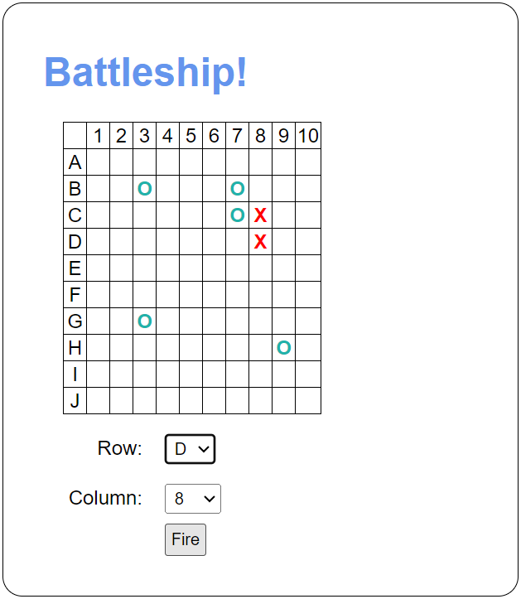

## Specifications

* Use an array to represent each row. The rows should use an O to represent water and an X to represent part of a ship.
* There are five ships:

1. Aircraft carrier: length 5
2. Battleship: length 4
3. Cruiser: length 3
4. Submarine: length 3
5. Destroyer: length 2.

* When the Fire button is clicked, the app should check that the user selected a row and a column. If so, the app should place a red X on the grid to indicate a hit or a light sea green O to indicate a miss.